

**Name__________________________________ # ____ Block ____**

**Due Date: _______________________________________________**

**Introduction to Shakespeare and His Language**

1. **Sonnet 18**
2. **If Shakespeare Wrote Songs-He’s So Fancy: Paraphrasing**
3. **Anticipation Guide**
4. **Moral Compass**
5. **Shakespearean Insult Kit**

**Notebook Check 1: SONNET 18 by William Shakespeare**

**Define Sonnet: ____________________________________________________________________________________________________________________________________________________________________________________________________________________________________________________________________________________________________________________**

**Define Paraphrasing: ____________________________________________________________________________________________________________________________________________________________________________________________________________________________________________________________________________________________________________________**

**SONNET 18 by William Shakespeare**

________________________________________________________________________________________________________________________________________________________________________________________________________________________________________________________________________________________________________________________________________________________________________________________________________________________________________________________________________________________________________________________________________________________________________________________________________________________________________________________________________________________________________________________________________________________________________________________________________________________________________________________________________________________________________________

Shall I compare thee to a summer's day?   
Thou art more lovely and more temperate:  
Rough winds do shake the darling buds of May,  
And summer's lease hath all too short a date:   
Sometime too hot the eye of heaven shines,  
And often is his gold complexion dimm'd;   
And every fair from fair sometime declines,  
By chance, or nature's changing course, untrimm'd;  
But thy eternal summer shall not fade  
Nor lose possession of that fair thou ow'st;  
Nor shall Death brag thou wander'st in his shade,  
When in eternal lines to time thou grow'st;   
So long as men can breathe or eyes can see,  
So long lives this, and this gives life to thee.

**Important terms: rhyme scheme, quatrain, couplet, iambic pentameter**

**Notebook Check 2: If Shakespeare Wrote Songs-He’s So Fancy**

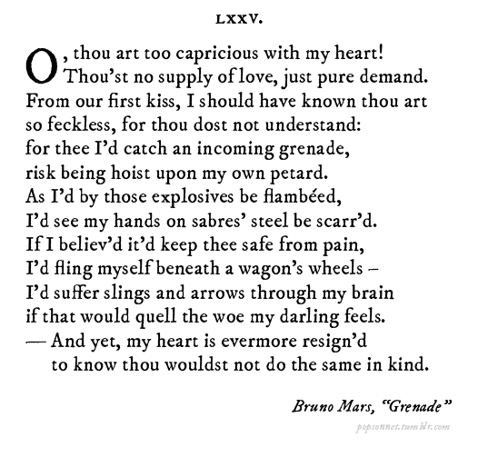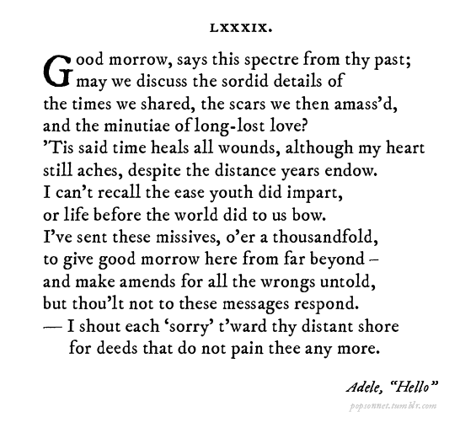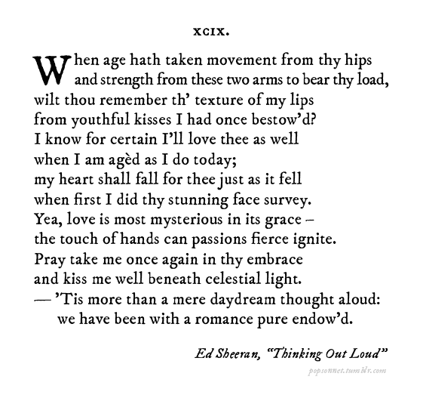

**Paraphrase of Class Choice:**

________________________________________________________________________________________________________________________________________________________________________________________________________________________________________________________________________________________________________________________________________________________________________________________________________

________________________________________________________________________________________________________________________________________________________________________________________________________________________________________________________________________________________________________________________________________________________________________________________________________

________________________________________________________________________________________________________________________________________________________________________________________________________________________________________________________________________________________________________________________________________________________________________________________________________

______________________________________________________________________________________________________________________________________________________________________________________________________________________________________________________________________________________________________

**LITERARY TERMS**: Define each term.

Tragedy:________________________________________________________________________________________________________________________________________________________________________________   
Fate:___________________________________________________________________________________________________________________________________________________________________________________________________________

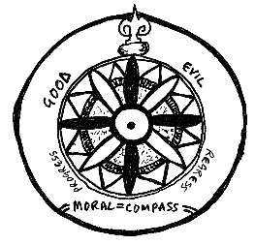

**Notebook Check 3: What’s a Moral Compass?**

**Directions:** Rank the following Offenses from 1-10, 10 being the MOST SERIOUS.



* Two families having a feud/fight 1 2 3 4 5 6 7 8 9 10
* Giving the middle finger 1 2 3 4 5 6 7 8 9 10
* Crashing a party (going uninvited) 1 2 3 4 5 6 7 8 9 10
* Lying to Parents 1 2 3 4 5 6 7 8 9 10
* Advising someone to marry for money or looks 1 2 3 4 5 6 7 8 9 10
* Marrying against parents’ wishes 1 2 3 4 5 6 7 8 9 10
* Cursing 1 2 3 4 5 6 7 8 9 10
* Selling potentially lethal drugs 1 2 3 4 5 6 7 8 9 10
* Picking a fight 1 2 3 4 5 6 7 8 9 10
* Killing someone during a fight 1 2 3 4 5 6 7 8 9 10
* Killing someone in self-defense 1 2 3 4 5 6 7 8 9 10
* Killing someone for revenge 1 2 3 4 5 6 7 8 9 10
* Committing suicide 1 2 3 4 5 6 7 8 9 10

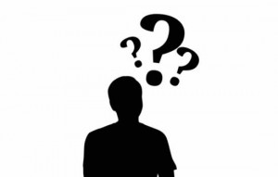What do you feel most strongly about? Why?

**Notebook Check 4: Anticipation Guide: Make Decisions About Your Beliefs**

Directions: Consider the romantic relationships in your life: your parents, your aunts and uncles, your siblings, and/or your own. Use your knowledge and experience to make a judgement about each of the claims. Circle either Strong Agree (SA), Agree (A), Disagree (D) or Strongly Disagree (SD).

1. There is such a thing as love at first sight. SA A D SD
2. If I am attracted to someone, I’ll find a way to see SA A D SD

him/her even if my parents tell me not to.

1. My parents will have to really like the person I SA A D SD  
   marry, or I won’t get marry him/her.
2. Boyfriends or girlfriends are more important than family. SA A D SD
3. You should know someone for at least a year

before you marry them. SA A D SD

1. Parents know what is best for their children more SA A D SD  
    than the children themselves.
2. Your parents should approve of the people that you SA A D SD

choose to date.

1. People who marry too young are likely to regret it. SA A D SD
2. It is better to take love slowly than to rush into SA A D SD  
   things and act on impulse.
3. Someone who is 14 years old is capable of making SA A D SD  
   decisions about love and marriage.
4. There are times when it is right to disobey one’s SA A D SD  
   parents.
5. Sometimes it’s okay to reveal a secret. SA A D SD
6. Feelings of love and passion do not prevent people SA A D SD  
   from making wise decisions.
7. I would die or kill for romantic love. SA A D SD
8. Hate is a more powerful emotion than love. SA A D SD
9. The choices we make determine our lives, not SA A D SD  
    fate or destiny.

1. Teenagers do not know what true love really feels like. SA A D SD
2. Being separated from a person you love is worse SA A D SD  
   than death.

**SHAKESPEAREAN WORDS**

anon = at once

art = are

ay = yes

cousin = any relative

doth = does

ere = before

hark = listen

hath = has

hither = near or to a place

i’ = in

nay = no

o’ = of

o’er = over

pray = please

prithee = please

quoth = said

shalt = shall

sooth = truth

th’ = the

thee = you

thine = yours (possessive)

thou = you (informal)

thy = your

till = until

‘tis = it is

whence = what, where, or when

wherefore = why

|  |
| --- |
| whither = where (from where) |

withal = within

wrought = made





**Notebook Check 5: Shakespeare Insult Kit:**

**Each of these words comes from works of Shakespeare.** Combine one word from each of the three columns below on a folded sheet of paper, prefaced with "Thou" in order to create an insulting phrase for display. Use color and your artistic ability to make the insults come to life. Be sure to include a brief explanation of what it means.

**Column 1** **Column 2** **Column 3**

artless base-court apple-john

bawdy bat-fowling baggage

beslubbering beef-witted barnacle

bootless beetle-headed bladder

churlish boil-brained boar-pig

cockered clapper-clawed bugbear

clouted clay-brained bum-bailey

craven common-kissing canker-blossom

currish crook-pated clack-dish

dankish dismal-dreaming clotpole

dissembling dizzy-eyed coxcomb

droning doghearted codpiece

errant dread-bolted death-token

fawning earth-vexing dewberry

fobbing elf-skinned flap-dragon

froward fat-kidneyed flax-wench

frothy fen-sucked flirt-gill

gleeking flap-mouthed foot-licker

goatish fly-bitten fustilarian

gorbellied folly-fallen giglet

impertinent fool-born gudgeon

infectious full-gorged haggard

jarring guts-griping harpy

loggerheaded half-faced hedge-pig

lumpish hasty-witted horn-beast

mammering hedge-born hugger-mugger

mangled hell-hated joithead

mewling idle-headed lewdster

paunchy ill-breeding lout

pribbling ill-nurtured maggot-pie

puking knotty-pated malt-worm

puny milk-livered mammet

qualling motley-minded measle

rank onion-eyed minnow

reeky plume-plucked miscreant

roguish pottle-deep moldwarp

ruttish pox-marked mumble-news

saucy reeling-ripe nut-hook

spleeny rough-hewn pigeon-egg

spongy rude-growing pignut

surly rump-fed puttock

tottering shard-borne pumpion

unmuzzled sheep-biting ratsbane

vain spur-galled scut

venomed swag-bellied skainsmate

villainous tardy-gaited strumpet

warped tickle-brained varlot

wayward toad-spotted vassal

weedy unchin-snouted whey-face

yeasty weather-bitten wagtail